| Please choose a lesson, or type 0 to return to course menu.

1: Basic Building Blocks 2: Workspace and Files 3: Sequences of Numbers

4: Vectors 5: Missing Values 6: Subsetting Vectors

7: Matrices and Data Frames 8: Logic 9: Functions

10: lapply and sapply 11: vapply and tapply 12: Looking at Data

13: Simulation 14: Dates and Times 15: Base Graphics

Selection: 15

| | 0%

| One of the greatest strengths of R, relative to other programming languages, is the ease with which we

| can create publication-quality graphics. In this lesson, you'll learn about base graphics in R.

...

|== | 2%

| We do not cover the more advanced portions of graphics in R in this lesson. These include lattice,

| ggplot2 and ggvis.

...

|==== | 4%

| There is a school of thought that this approach is backwards, that we should teach ggplot2 first. See

| http://varianceexplained.org/r/teach_ggplot2_to_beginners/ for an outline of this view.

...

|======= | 7%

| Load the included data frame cars with data(cars).

> data(cars)

| Perseverance, that's the answer.

|========= | 9%

| To fix ideas, we will work with simple data frames. Our main goal is to introduce various plotting

| functions and their arguments. All the output would look more interesting with larger, more complex data

| sets.

...

|=========== | 11%

| Pull up the help page for cars.

> ?cars

| You got it right!

|============= | 13%

| As you can see in the help page, the cars data set has only two variables: speed and stopping distance.

| Note that the data is from the 1920s.

...

|=============== | 16%

| Run head() on the cars data.

> head(cars)

speed dist

1 4 2

2 4 10

3 7 4

4 7 22

5 8 16

6 9 10

| That's a job well done!

|================= | 18%

| Before plotting, it is always a good idea to get a sense of the data. Key R commands for doing so

| include, dim(), names(), head(), tail() and summary().

...

|==================== | 20%

| Run the plot() command on the cars data frame.

> plot(cars)

| You are really on a roll!

|====================== | 22%

| As always, R tries very hard to give you something sensible given the information that you have provided

| to it. First, R notes that the data frame you have given it has just two columns, so it assumes that you

| want to plot one column versus the other.

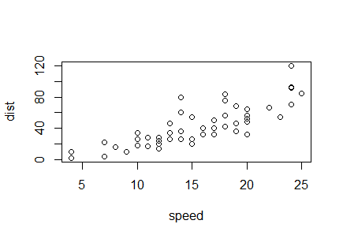

...

|======================== | 24%

| Second, since we do not provide labels for either axis, R uses the names of the columns. Third, it

| creates axis tick marks at nice round numbers and labels them accordingly. Fourth, it uses the other

| defaults supplied in plot().

...

|========================== | 27%

| We will now spend some time exploring plot, but many of the topics covered here will apply to most other

| R graphics functions. Note that 'plot' is short for scatterplot.

...

|============================ | 29%

| Look up the help page for plot().

> ?plot

| You are doing so well!

|============================== | 31%

| The help page for plot() highlights the different arguments that the function can take. The two most

| important are x and y, the variables that will be plotted. For the next set of questions, include the

| argument names in your answers. That is, do not type plot(cars$speed, cars$dist), although that will

| work. Instead, use plot(x = cars$speed, y = cars$dist).

...

|================================= | 33%

| Use plot() command to show speed on the x-axis and dist on the y-axis from the cars data frame. Use the

| form of the plot command in which vectors are explicitly passed in as arguments for x and y.

> plot(x = cars$speed, y = cars$dist)

| Nice work!

|=================================== | 36%

| Note that this produces a slightly different answer than plot(cars). In this case, R is not sure what you

| want to use as the labels on the axes, so it just uses the arguments which you pass in, data frame name

| and dollar signs included.

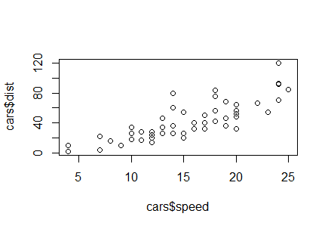

...

|===================================== | 38%

| Note that there are other ways to call the plot command, i.e., using the "formula" interface. For

| example, we get a similar plot to the above with plot(dist ~ speed, cars). However, we will wait till

| later in the lesson before using the formula interface.

...

|======================================= | 40%

| Use plot() command to show dist on the x-axis and speed on the y-axis from the cars data frame. This is

| the opposite of what we did above.

> plot(x = cars$dist, y = cars$speed)

| Keep working like that and you'll get there!

|========================================= | 42%

| It probably makes more sense for speed to go on the x-axis since stopping distance is a function of speed

| more than the other way around. So, for the rest of the questions in this portion of the lesson, always

| assign the arguments accordingly.

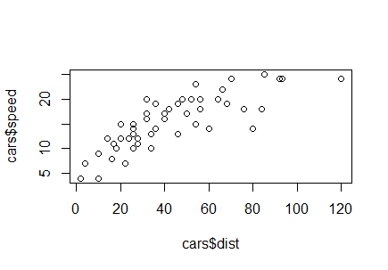

...

|============================================ | 44%

| In fact, you can assume that the answers to the next few questions are all of the form plot(x =

| cars$speed, y = cars$dist, ...) but with various arguments used in place of the ...

...

|============================================== | 47%

| Recreate the plot with the label of the x-axis set to "Speed".

> plot(x = cars$speed, y = cars$dist, xlab = "Speed")

| All that hard work is paying off!

|================================================ | 49%

| Recreate the plot with the label of the y-axis set to "Stopping Distance".

> plot(x = cars$speed, y = cars$dist, ylab = "Stopping Distance")

| Great job!

|================================================== | 51%

| Recreate the plot with "Speed" and "Stopping Distance" as axis labels.

> plot(x = cars$speed, y = cars$dist, xlab = "Speed", ylab = "Stopping Distance")

| All that hard work is paying off!

|==================================================== | 53%

| The reason that plots(cars) worked at the beginning of the lesson was that R was smart enough to know

| that the first element (i.e., the first column) in cars should be assigned to the x argument and the

| second element to the y argument. To save on typing, the next set of answers will all be of the form,

| plot(cars, ...) with various arguments added.

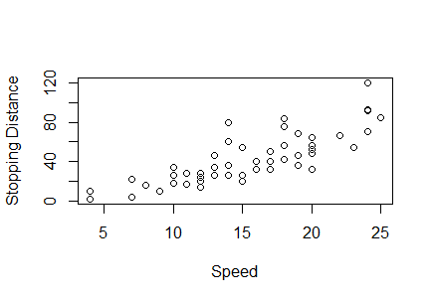

...

|====================================================== | 56%

| For each question, we will only want one additional argument at a time. Of course, you can pass in more

| than one argument when doing a real project.

...

|========================================================= | 58%

| Plot cars with a main title of "My Plot". Note that the argument for the main title is "main" not

| "title".

> plot(cars, main = "My Plot")

| All that hard work is paying off!

|=========================================================== | 60%

| Plot cars with a sub title of "My Plot Subtitle".

> plot(cars, sub = "My Plot Subtitle")

| All that practice is paying off!

|============================================================= | 62%

| The plot help page (?plot) only covers a small number of the many arguments that can be passed in to

| plot() and to other graphical functions. To begin to explore the many other options, look at ?par. Let's

| look at some of the more commonly used ones. Continue using plot(cars, ...) as the base answer to these

| questions.

...

|=============================================================== | 64%

| Plot cars so that the plotted points are colored red. (Use col = 2 to achieve this effect.)

> plot(cars, col = 2)

| Perseverance, that's the answer.

|================================================================= | 67%

| Plot cars while limiting the x-axis to 10 through 15. (Use xlim = c(10, 15) to achieve this effect.)

> plot(cars, xlim = c(10, 15))

| Nice work!

|==================================================================== | 69%

| You can also change the shape of the symbols in the plot. The help page for points (?points) provides the

| details.

...

|====================================================================== | 71%

| Plot cars using triangles. (Use pch = 2 to achieve this effect.)

> plot(cars, pch = 2)

| You're the best!

|======================================================================== | 73%

| Arguments like "col" and "pch" may not seem very intuitive. And that is because they aren't! So,

| many/most people use more modern packages, like ggplot2, for creating their graphics in R.

...

|========================================================================== | 76%

| It is, however, useful to have an introduction to base graphics because many of the idioms in lattice and

| ggplot2 are modeled on them.

...

|============================================================================ | 78%

| Let's now look at some other functions in base graphics that may be useful, starting with boxplots.

...

|============================================================================== | 80%

| Load the mtcars data frame.

> data(mtcars)

| Excellent work!

|================================================================================= | 82%

| Anytime that you load up a new data frame, you should explore it before using it. In the middle of a

| swirl lesson, just type play(). This temporarily suspends the lesson (without losing the work you have

| already done) and allows you to issue commands like dim(mtcars) and head(mtcars). Once you are done

| examining the data, just type nxt() and the lesson will pick up where it left off.

...

|=================================================================================== | 84%

| Look up the help page for boxplot().

> ?boxplot

| Your dedication is inspiring!

|===================================================================================== | 87%

| Instead of adding data columns directly as input arguments, as we did with plot(), it is often handy to

| pass in the entire data frame. This is what the "data" argument in boxplot() allows.

...

|======================================================================================= | 89%

| boxplot(), like many R functions, also takes a "formula" argument, generally an expression with a tilde

| ("~") which indicates the relationship between the input variables. This allows you to enter something

| like mpg ~ cyl to plot the relationship between cyl (number of cylinders) on the x-axis and mpg (miles

| per gallon) on the y-axis.

...

|========================================================================================= | 91%

| Use boxplot() with formula = mpg ~ cyl and data = mtcars to create a box plot.

> boxplot(formula = mpg ~ cyl, data = mtcars)

| You're the best!

|=========================================================================================== | 93%

| The plot shows that mpg is much lower for cars with more cylinders. Note that we can use the same set of

| arguments that we explored with plot() above to add axis labels, titles and so on.

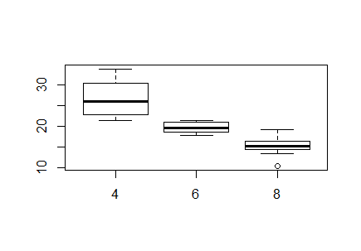

...

|============================================================================================== | 96%

| When looking at a single variable, histograms are a useful tool. hist() is the associated R function.

| Like plot(), hist() is best used by just passing in a single vector.

...

|================================================================================================ | 98%

| Use hist() with the vector mtcars$mpg to create a histogram.

> hist(mtcars$mpg)

| You are really on a roll!

|==================================================================================================| 100%

| In this lesson, you learned how to work with base graphics in R. The best place to go from here is to

| study the ggplot2 package. If you want to explore other elements of base graphics, then this web page

| (http://www.ling.upenn.edu/~joseff/rstudy/week4.html) provides a useful overview.



